# Lesson 84 单词讲解

busman ['bʌsmən] n.公共汽车司机

state [steit] v.正式提出，宣布

agreement[ə'gri:mənt] n.协议

pressure ['preʃə] n.压力，麻烦

volunteer [ˌvɔlən'tiə] v.自动提出，自愿

gratitude ['grætitju:d] n.感激

object ['ɔbdʒiktˌ əb'dʒekt] v.不赞成，反对

strike n. 罢工v. 敲打，撞击，罢工

go on strike

Be on strike

1. relieve v. 减轻 relieve the pressure / stress relief n. 减轻，解除，安慰
2. extent n. 程度 to some extent To some extent, this is a good article.
3. press v. 按，压

press the button

press any key to continue

n. 出版社，新闻界

Foreign Language Teaching and Research Press pressure n. 压力

# Lesson 84 课文&语法讲解

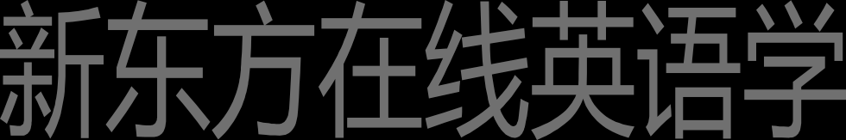本课重点:

复习一般将来时

形 式 宾 语 it ／ 真 正 的 宾 语 to do 1.Busmen have decided to go on strike next week. 2.The strike is due to begin on Tuesday.

1. No one knows how long it will last.
2. The busmen have stated that the strike will continue until general agreement is reached about pay and working conditions.
3. Most people believe that the strike will last for at least a week.
4. Many owners of private cars are going to offer 'free rides' to people ...
5. This will relieve pressure on the trains to some extent.
6. All the students are expert drivers, but before they drive … , they will have to pass a special test.
7. The students are going to take the test in two days' time.
8. … people are going to find it difficult to get to work.

形式宾语 it

真正的宾语 to do

在这个句子中,it是动词find的宾语,difficult作it的补足语.这个句子也可以改成以that引导的宾语从句：people are going to find that it is difficult to get to work.在这个宾语从句中,it作从句的主语,difficult作表...

人们发现出国旅行非常有趣。

People find it very interesting to travel abroad.

10.… people are going to find it difficult to get to work.

形式宾语 it

真正的宾语 to do

我们发现没有钱去生活很困难。

We find it very hard to live without money.

10.… people are going to find it difficult to get to work.

形式宾语 it

真正的宾语 to do

我们知道顺利地解决问题不可能。

We knew it impossible to solve the problem smoothly.

1. … people are going to find it difficult to get to work.

形式宾语 it

真正的宾语 to do / 从句

我认为我们应该受到惩罚这事是对的。

I think it right that we should be punished.

改造

I think it is right that we should be punished.

主 谓 宾语从句 it is right 后面that 又是一个定语从句

1. But so far, the public has expressed its gratitude to the students in letters to the Press.

表达感谢：

Thank you (very much). Thanks (a lot).

I really appreciate you / your help. I am truly grateful to you.

I’d like to express my gratitude to you.

1. Only one or two people have objected that the students will drive too fast !

本课重点:

复习一般将来时

形式宾语 it ／真正的宾语 to do

# Lesson 84 知识拓展

本课重点:

形式宾语 it

形式主语 it

… people are going to find it difficult to get to work.

形式宾语 it

真正的宾语 to do / 从句

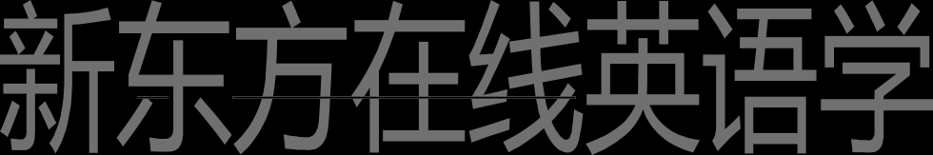

我认为我们应该受到惩罚这事是对的。

I think it right that we should be punished.

It was his job to repair bicycles …

= To repair bicycles was his job.

形式主语 it

真正的主语 to do

It was obvious that he was very embarrassed.

＝ That he was very embarrassed was obvious.

形式主语 it

真正的主语 从句（主语从句）

It is said that if anyone touches the tree, he will have bad luck; if he picks a leaf, he will die.

本课重点: 形式宾语 it 形式主语 it

